**2353569_WSOA3003A_Game Design Document_June**

**Aim**

aims to increase player involvement through the screen and game experience by challenging players meanwhile giving them excitement and a sense of success.

**Hypothesis**

How can Feedback and communication be increased through new gaming experiences?

**A Genre and subgenre analysis:**

Looking at how I made my game I decided to take a different approach and created a new game with the same inspirations from the ones I used in my Assignment 3. The reason for this was due to having a lot of errors and dead ends in improving my Top-down game that I made and the way I wanted UI to communicate and engage with the player.

**Enter The Gungeon Game**

Genre: roguelike twin-stick shooter & Top-Down Shooter

This game focuses on the player's character killing enemies using different weapons. Weapons include guns and long-range instruments like grenades, as well as Armor and accessories like telescopic sights. Ammunition, Armor, and health pickups are frequently available, as well as the option of changing guns for better effectiveness.

The features in the game, Conventions, Characteristics, and Tropes:

The popular roguelike computer game "Enter the Gungeon" combines dungeon exploring concepts with furious bullet hell gameplay. It features randomly generated dungeon layouts that provide different experiences with every game you play. When a player's character dies, they must restart from the beginning, making the game more difficult.

"Enter the Gungeon"'s basic gameplay include dungeon crawling, roguelike elements, shooting mechanics, bullet hell, and monster levels. Players navigate quickly created levels filled with enemies, traps, and prizes.

Each floor has its different theme and ends with a difficult boss battle. Players control a figure armed with numerous firearms and weapons, moving through crowds of enemies while avoiding bullets.

Bullet hell elements are strongly highlighted in the game, with advanced opponent projectile patterns that put players' abilities to the test. It’s totally different combination of roguelike rules, bullet hell action, and a wide variety of weapons and equipment has led to its success and popular following. The game's difficult gameplay, replay ability, as well as its unique visual aesthetic establish it as a sub-genre within the wider roguelike and bullet hell genres.

The game's major takeaways include the mechanics of level structure and design, player shooting and movement, and opponent attack patterns. For gamers looking for a tough and intense gaming experience, "Enter the Gungeon" provides an interesting and pleasant experience.

**Expandabros Game**

Genre: run and gun or action platformer.

Expandabros is a platformer action game with a "run and gun" gameplay style. Players progress through stages while fighting with a range of tough weaponry. To overcome difficult battles, players must mix getting around and shooting skills.

Expandabros is a platformer with serious level design that includes accurate jumping, obstacles, and secret parts. To solve platforming tasks, players must demonstrate agility and accuracy.

The game has a progression system that allows players to acquire new characters, weapons, power-ups, and upgrades as they complete tasks and kill enemies. This creates a sense of growth and recognises players' achievements.

The game's difficulty, the use of UI components to show player health, and the importance of clear and visually attractive images for showing player health and times are all key takeaways from playing Expandabros.

Expandabros provides an exciting and demanding gaming experience with a focus on platforming, combat, and player advancement.

**Design notes & process:**

**Design Flow:**

I decided to change my game from a top-down game to a shoot 'em up space shooter to provide a more engaging and action-packed experience for players. The shift to a shoot 'em up genre allows for intense and fast-paced gameplay, where players can engage in thrilling space battles, dodge enemy projectiles, and unleash devastating firepower. This change opens a whole new level of excitement and challenge, as players navigate through enemy-infested space environments and encounter epic boss fights.

Additionally, the space shooter genre offers a visually captivating experience with its vibrant and dynamic backgrounds, futuristic spacecraft designs, and explosive special effects. The change allows me to tap into the excitement and nostalgia associated with classic shoot 'em up games, providing players with a sense of nostalgia while incorporating modern elements and innovative mechanics. By embracing the shoot 'em up genre, my game can deliver an adrenaline-fueled adventure that engages players in the thrilling world of space combat and allows them to unleash their inner hero against relentless foes.

I designed my game by brainstorming and outlining it before building it. The game was inspired by Run n Gun Games, featuring various enemies and levels for players to go through. I decided to use the core mechanics for the games mentioned above to create a space game.

Deciding on the weapon ammo system was a crucial aspect of the design. I opted for unlimited ammo (Bullets) like bullet hell to create a more interactive and pressure-filled experience for players. Unlimited ammo has made my game to be more engaging and for the player to be cautious about where they shoot, as a screen filled with bullets would make a player not see where they are. It gives the sense of challenge and strategic decision-making.

I have a reset method that makes a player go back to the start of the level that they are currently playing and not Level one. In this way the player does not get bored of the game easily because of having to start from the start and loosing all the progression a player has made in the game.

Having a reset system provides flexibility in balancing the game's difficulty. It enabled me to create challenging encounters without making the game overly punishing. In this way the mechanics maintains player engagement and encourages resilience in the presence of difficulty.

Overall, my game design was for me to offer players an engaging and challenging experience through unlimited ammo, game choices(power-ups), and reset system.

**System Structure:**

The game system structure is the game engine, as it provides the underlying framework for the game. It handles key tasks such as rendering graphics, managing input from players, and handling physics simulations.

Having an input System is important, it captures player input from different sources, such as a keyboard, mouse, or gamepad. It converts these inputs into commands that can be interpreted and processed by the game's logic.

The Game Logic subsystem contains the rules and algorithms that govern the behavior and interactions within the game. It includes components such as character movement, enemy AI, collision detection, shooting mechanics, and overall game progression.

The level design subsystem encompasses the creation and management of game levels or environments. It includes tools and processes for designing, constructing, and populating levels with objects, obstacles, enemies, and interactive elements. This subsystem may also handle level loading, saving, and transitioning between different areas.

**Ideal Screenshot:**

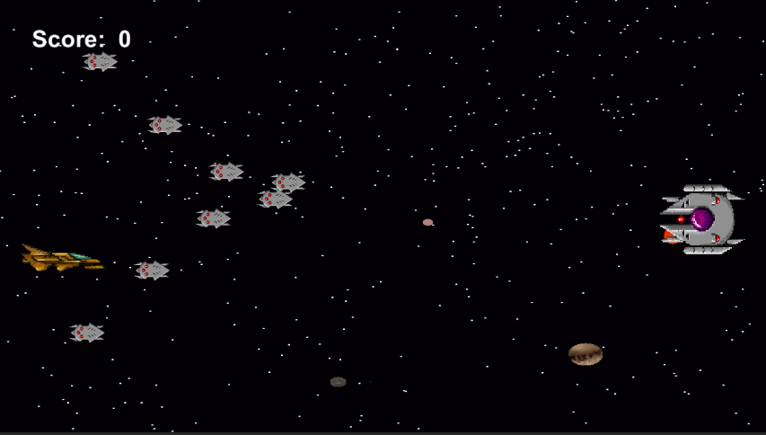

Above is how my Game is intended to look with the different features in enemies and text. It is still the beginning and has a lot that comes with it, challenges and some difficulties that a player can be on the lookout for.

**Level Design:**

In my level design process, I aim to create engaging levels that increase the gameplay experience. I strategically placed enemies to offer tactical advantages and test the player's shooting skills and defensive abilities. To increase the challenge, I implemented different waves of enemies. I also experimented with different enemy types and behaviors to create diverse and fresh encounters.

The level layout was relatively straightforward, consisting of a space-like environment with stars and galactic look. This layout served to create a sense of exploration and limited enemy access, leading to intense moments where the player faced multiple enemies simultaneously.

**Design Process:**

The game design process for my game involved carefully thinking of different gameplay elements such as player movement, player health, which is not represented in UI, reset level, player Gun, enemies that shoot and those who run into you, and a boss level at the end of each level. Each of these components are crucial in creating an immersive and engaging (as mentioned above) gaming experience.

To ensure a satisfying player experience, I focused on adaptation and understanding player movement controls, allowing players to navigate the game world easily. Not knowing the player health added suspense and risk dynamics, requiring strategic resource management and rewards (Powerups).

Originally envisioning an expandable environmental and level layout style, I adapted my design to a top-down platform perspective, allowing more focus on UI elements. I added different powerups as collectible items and planned to introduce upgrades that players could have after completing a level.

While considering feedback as an important aspect of game communication, I opted to primarily use UI elements to be the communication to the player and give information. Additionally, I had ideas for enemy sprites with animations to add visual interest and unique movement patterns to the game.

**Game-Inspirations**

In Nuclear throne, I used the mechanics of a player being able to move around and encounter enemies. I am drawn to Nuclear Throne's diverse character abilities, weapon variety, and challenging boss fights. In my game, I want to offer players a range of spaceship options or pilots, each with unique abilities that complement different playstyles. By providing a variety of weapons, I can empower players to customize their loadout and experiment with different strategies against the hostile alien forces.

Playing Expandabros, I took away the aspect of platform movement and shooting with also the way in the game had different ways a player can get health and weapons depending on the character that is visible at that time. The use of UI as a game component helped in communicating and me having a better game experience.

The aspect that inspires me is Enter the Gungeon's combination of bullet hell mechanics with dungeon-crawling elements. By incorporating bullet hell gameplay, my game can offer intense and intricate patterns of enemy projectiles, challenging players' reflexes and direct skills. Additionally, the inclusion of dungeon-crawling mechanics allows players to go through into procedurally generated levels, uncovering secrets, and facing off against challenging bosses. This blend of genres creates a distinct and thrilling experience for players in my space shooting game.

**Reflection:**

Looking back at the first game I designed which was a top-down game that had featured the above-mentioned game mechanics but didn’t work out to what I had in mind. The top-down game did not give players much of a game experience and had dead ends through out the gameplay.

In my space shooting game, I have created a 2D top-down experience where players navigate and combat enemies. The game follows a classic genre, offering straightforward and enjoyable gameplay with level progression.

Player movement and enemy AI are key mechanics. Allowing players to control their ship adds interactivity, while AI-driven enemies with Pathfinder AI create challenging and dynamic encounters. Enemy respawns and strategically placed respawn points maintain urgency and variety.

UI elements like a timer and health system provide important information. The timer adds urgency and potential challenges, while the health system requires strategic management. While acknowledging areas for improvement, such as graphics or level design, I will focus on iterating and refining the game based on feedback and observations.

Overall, the game has a strong foundation with core mechanics like player and enemy movement, respawns, and health systems. Enhancements could involve additional features, improved level design, and overall polish to create a more immersive and engaging space shooting experience.

Looking back at the game I had made to what I have created, I would say that going back to the drawing board and rethinking my new game has helped me to achieve some of what I want to achieve. Knowing what is needed and having a great game genre for it helped me know how to implement it.

**Bibliography**

**-**Hachman, M., 2015. Surface 3: *this is the one worth recommending, though it's no bargain*. *PC World*, pp.44-52.

-Singhal, T. and Schneider, O., 2021, May. Juicy haptic design: Vibrotactile embellishments can improve player experience in games. In *Proceedings of the 2021 CHI Conference on Human Factors in Computing Systems* (pp. 1-11).

-Technical-analysis-explained-the-successful-investors-guide-to-spotting-investment-trends-and-turning-points-Martin-J.-Pring-Booktree

-Rubio-Manzano, C. and Trivino, G. (2016) “Improving player experience in Computer Games by using players’ behavior analysis and linguistic descriptions,” *International Journal of Human-computer Studies*, 95, pp. 27–38. Available at: <https://doi.org/10.1016/j.ijhcs.2016.07.002>.

-Rienzo, A. and Cubillos, C. (2020) “Playability and Player Experience in Digital Games for Elderly: A Systematic Literature Review,” *Sensors*, 20(14), p. 3958. Available at: <https://doi.org/10.3390/s20143958>.

-Cairns, P., Cox, A. and Nordin, A.I., 2014. Immersion in digital games: a review of gaming experience research. *Handbook of digital games*, pp.337-361.

Williams, A., 2017. *History of digital games: developments in art, design, and interaction*. CRC Press.